2016 Election Results

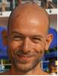  Fausto Franceschini  Chair  Fellow Engineer, Westinghouse Electric Company | 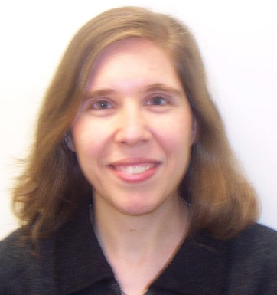  Arzu Alpan  Vice Chair  Principal Engineer, Radiation Engineering & Analysis Group, Westinghouse Electric Company, Cranberry Township, PA
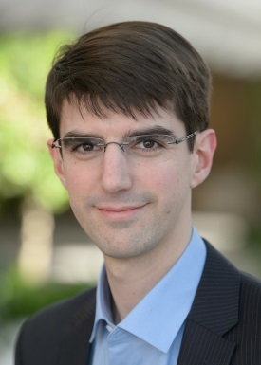  Florent Heidet  Secretary  Principal Nuclear Engineer, Argonne National Laboratory, Argonne, IL | 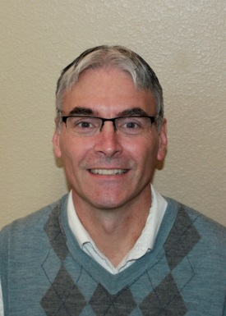  Todd S. Palmer  Treasurer  Professor, School of Nuclear Science and Engineering, Oregon State University, Corvallis, OR.
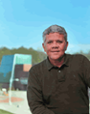  Luiz C. Leal  Executive Committee  Presently Deputy of the Laboratory of Expertise and Research in Neutron Reactor Applications at the Institut de Radioprotection Sûreté Nucléaire (IRSN), France | 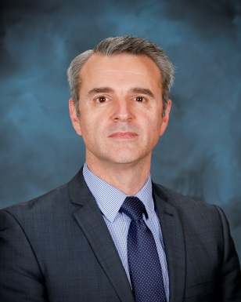  Andrew Worrall  Executive Committee  Senior Scientist, Reactor Physics Group, Oak Ridge National Laboratory
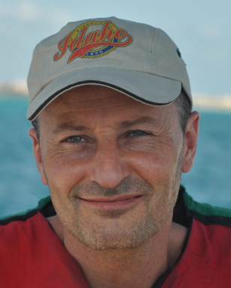  Gilles J. Youinou  Executive Committee  Department Manager, Reactor Physics Analysis & Design, Idaho National Laboratory | 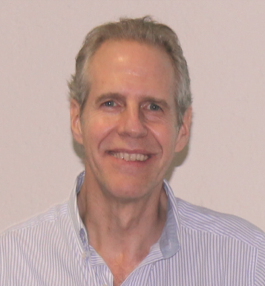  Juan-Luis François  Executive Committee-Non-US - RPD  Professor, National Autonomous University of Mexico

